OUR MISSION  MATTHEW 11: 25-30  ARE YOU SATISFIED WITH THE LIFE YOU ARE LIVING IN EVERY AREA?  We here at Yeshuwa’s Table of Refuge Out Reach Center Inc. believe that YHWH “THE GOD OF ISRAEL”IS OUR REFUGE AND STRENGTH. (Psalm 46). The son of the living god of Israel will return and set up our eternal kingdom on this earth. (Jeremiah 31: 1-40). The whole Holy Bible is our foundation upon which we believe, as it is written to the law and to the testimony, line upon line, precept upon precept. (Isaiah 8: 19-20). Our Mission until he returns is to restore godly love and bring about salvation that YHWH intended for us to have throughout our communities. We are our brothers’ keeper.  The death and resurrection of Yeshuwa the Messiah, though we await his coming kingdom, he has given us power to receive deliverance, security, preservation, healing, self-control, peace, and prosperity from the garment of salvation right here and now.  For the kingdom of god is not meat and drink; but righteousness, and peace, and joy in the Holy Ghost. |  | Address  5175 Scarbrough LN STONE MTN, GA 30088  contact us  The Phone Number | 404-453-6748 | Rev.Kenrick E.Yearwood JR  www.theshoutingtrumpet.wordpress.com  https://www.youtube.com/channel/UCxIIT-8eAQ-W_bfuHF3ybhQ?view_as=subscriber  https://us04web.zoom.us/j/5847413713?pwd=QWFPWVZBWmRyRFFtT0JUM2VlVWVPUT09  https://www.facebook.com/kenrick.yearwood.96/   |  | - a savor and a light to all  pillars to live by:  - PS 46  - Deut.5:1-22  - Math.11: 25-30  - 1 John 1: 8-10  - 1 John 2: 2-6  - Rev.3: 14-19  - SHEMA  - Deut 6: 4-9  - Deut.11: 13-21  - Num.15: 37-41  we offer the following services:  - BIBLICAL MENTORING COUNSELING  - PRAYER LINE  - BIBLE STUDY CLASSES  - PEER SUPPORTER  Yeshuwa’s Table ofrefuge outreach center incorporated plans to offer the following services throughout the community in the near future:  - Homeless shelter  - Soup kitchen  - Job training and placement  - Drug counseling  - Job training and placement for the disabled, etc.  - YESHUWA’S TABLE OF REFUGE OUTREACH CENTER  QUESTIONS FOR SALVATION:  - Are you satisfied with the life you living in every area?  - Can mankind save him or herself  - What is mankind saved or seeking to be saved from?  - Do you understand that through the vehicle of faith in spirit and in truth, that if you do not keep the commandments of YHWH, you cannot be saved?  - Do you understand what salvation is?  - Can you lose your salvation?  - Do you know Yeshuwa, Messiah, Jesus Christ?  - Do you know of satin and a place called HELL FIRE  - Do you know that whomever you yield your body to, that’s who you worship?  10.Do you know who you are and the role you play in YHWH salvation plan?  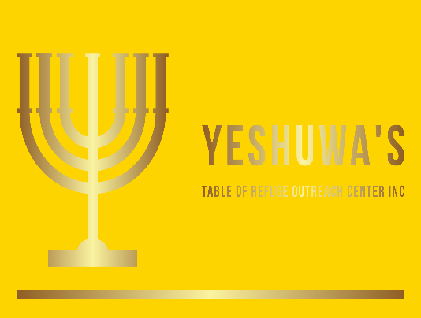

[Grab your reader’s attention with a great quote from the document or use this space to emphasize a key point. To place this text box anywhere on the page, just drag it.]
